* 1. **Project Profile**

Project Name - Online Freelancing

Developed by - Gaurav koradiya

Front End - PHP,wordpress

Back end - My SQL

**2.1 Hardware Specification**

Hardware Product is necessary part to run a system.here, we describe different hardware used in the computerized system.

**Hardware**

Processor : intelcore processor or above.

HardDisk : 100GB HD.

RAM : 1 GB of RAM.

**Software Specification**

Software also necessary as well as hardware to run a system.The Software is Used For the System.It may be In the form of application or operating system.

**Minimum Software Requirements**

Operating System:Windowsxp or above.

Browser (I.E, Firefox, Chrome,Microsoft Edge etc.)

Wamp Server

MySQL

Wordpress

**2.2 Front End**

**PHP**

PHP is the Web development language written by and for Web developers. PHP stands for Hypertext Preprocessor. The product was originally named Personal Home Page Tools.

PHP is a server side scripting language, which can be embedded in HTML.

“RasmusLerdorf”-software engineer, Apache team member, and international man of mystery is the creator and original driving force behind PHP. The first part of PHP was developed for his personal use in late 1994. This was a CGI wrapper that helped him keep track of people who looked at his personal site. The next year, he put together a package called the

Personal Home Page Tools.Version 2 was soon released under the title PHP/FI and included the Form Interpreter, a tool for parsing SQL queries. By the middle of 1997, PHP was being used on approximately 50,000 sites worldwide. It was clearly becoming too big for any single person to handle, even someone as focused and energetic as Rasmus. A small core development team now runs the project on the open source.The fourth quarter of 1998 initiated a period of explosive growth for PHP, as all open source technologies enjoyed massive publicity.

**Key Points :**

* PHP stands for Hypertext Preprocessor
* PHP is a server-side scripting language, like ASP
* PHP scripts are executed on the server
* PHP supports many databases (MySQL, Informix, Oracle, Sybase, Solid, PostgreSQL, Generic ODBC, etc.)
* PHP is an open source software
* PHP is free to download and use
* PHP files can contain text, HTML tags and scripts
* PHP files are returned to the browser as plain HTML
* PHP files have a file extension of ".php", ".php3", or ".phtml"

**2.3 Back End**

**MYSQL**

The database component of MYSQL is a Relation Database System support for Internet

applications. Each term describes a fundamental part of the architecture of the MYSQL

database component.

**Database:**

A Database is similar to a data file in that it storage place for data. Like a Data file, a database does not present information directly to a user; the user runs an application that fetch data from the database and presents it to the user in an understandable format.

DatabaseSystems are more powerful than data files. In welldesigned database, there is no duplicate value of data that the user or application must update at the same time. Related pieces of data are grouped together in a single structure.

A Database typically has two main parts: first, the file holding the physical database and

second, the database management system (DBMS) software that applications use to fetch and

store data. The DBMS is responsible for the Database structure including Maintaining relationships between data in the Database.

**Relational Database:**

There are different ways to organize data in different ways in database; relational databases are one of the most effective. Relational database systems are an application of mathematical set Theory to the problem of effectively organizing data. In a relation database, data is collected into tables.

A table represents some class of objects that are important to an organization. For example, a company may have a database with a table for employees, another table for customer, and another for stores. Each table is built of columns and rows. Each column represents some attribute of the object represented by the table. For example, an Employee table that have a column such as First Name, Last Name, EmpId, Department, and Job title.

**Several Advantage of My sql:**

* It’s one of the most popular database being used on the web today
* It’s freely available as a download to install and run on your own machine.
* It’s easy to install on a wide range of operating system (including windows and UNIX).
* It’s available as a relatively cheap feature in many web hosting packages.
* It’s simple to use and includes some handy administration tools.
* It’s fast, powerful client/server system that copes well with very large, complex database, and should stand you in good stead when it comes to large projects.

**2.4 Development Strategy**

To solve actual problems in an industry setting, software engineer or a team of engineers must incorporate a development strategy that encompasses the process, methods and tools layers and generic phase. This strategy is often referred to as process model or a software engineering paradigm. A process model for software engineering is often chosen based on the nature of the project and application, the methods and tools to be used, and the controls and deliverables that required.

To solve actual problems in an industry setting, a software engineer or a team of engineers must incorporate a development strategy that encompass the process, methods, and tool layers.

**Types of Software Process Models:**

The Linear sequential Model ( Waterfall Model)

The Prototyping Model

The Rapid Application Development (RAD) Model

The Incremental Model

The Spiral Model

**Waterfall Model:**

The waterfall model derivers its name due to the cascading effect from one phase to the

other as is illustrated in above figure. In this model each phase well define starting and ending

point,with identifiable deliveries to the next phase.

This model is sometime referred to as the linear sequential model or the software life cycle model.Starting from the existing situation, we proceed towards the desired solution in a number of steps. At each of these steps the Waterfall Model is followed. Consider a Linear sequential Modellifecycle model which consists of repeating the following five phases in sequence.

The waterfall diagram is basically divided into following 5 models.

* Requirement
* Design
* Implementation
* Verification
* Maintenance

**Requirement:**

In the requirement phase the need to create the application is specified. What is the

need of the system is defined. What information to be feeder to create the application will come

under the requirement phase?

**Design:**

After the requirement phase the next phase is the Design phase where the application is

designed according to the forms and other modules created. This phase is much important

phase because it will structure the layoutof your application.

**Implementation:**

Implementation is the process of having a system personnel phase check out and put new equipment into use, train users, install new application and construct any file of data need to use it.

**Verification:**

After the whole application is being the developed the main phase is the verification

phase where the whole application tested and verified to check the whole application.

**Maintenance:**

After the successful verification of the application the main phase is the maintenance

phase where the application needs to be maintained for its successful operation in future

**3.1 Current System**

* The traditional Online Freelancing System requires many complex tasks to be performed, so it is a tedious & time cumbersome job for the employee.
* Worker as well as developer of Online Freelancing has to record each detail through registration.
* They are so many thing including so employee is confused for identified their job.
* Worker as well as user both are doing long process for their work.

**SCOPE:**

* The scope for online freelance job opportunity is immense, because of the fact that it offers a Win-win situation for both the client and the service provider.
* Freelance job opportunities have never been very easy and reachable as they are now.
* Initially it may be slower to earn online, but there is a rising scope of getting income consistently from onlinejobs.
* All most all the companies have made their presence online for wider reach among the people all over the world.
* Internet technology has become a perfect medium for online business opportunities.

**4.1 E-R Diagram**

An Entity Relation of Diagram is a specialized graphics that illustrates the interrelationship between entities in a database. ER diagrams often use symbols to represent 3 different types of information. Boxes are commonly used to represent entities. Diamonds are normally used to represent relationships and ovals are used to represent attributes.

An Entity Relationship model (ERM), in software engineering is an abstract and conceptual represent of data. Entity Relationship modeling is a relational schema database modeling method, used to produce a type of conceptual schema or semantic data model of a system, often a relation database, and its requirements in a top-down fashion.

**Entity:**

Entity is the thing which we want to store information. It is an elementary basic building block of storing information about business process. An entity represents an object defined within the information system about which you want to store information. Entities are distinct things in the enterprise.

**Relationships**

A relationship is a named collection or association between entities or used to relate two or more entities with some common attributes or meaningful interaction between the objects.

**Attributes**

Attributes are the properties of the entities and relationship, Descriptor of the entity. Attributes are elementary pieces of information attached to an entity.



**4.2 Data Flow Diagram:**

Data Flow Diagram was introduced by De Marco (1978)andGane and Sarson(1979), and do system analysts use important tool. A data flow diagram models a system by using external entities from which data flows to a process which transforms the data and creates output data flows which goes to other processes or external entities or data stores.

The main merit of DFD is that it can provide an overview of what data a system would process, what transformations of data are done, what data are stored and which stored data are used, and where the result flows.

**Good Conventions in Developing DFD’s:**

Data Flow diagrams serve the dual purpose of specifying what data are needed for processing and as documentations of what procedures transform data.

**A good Data Flow Diagram should not have the follow:**

* Loops.
* A process, which is a poor decision.
* A Data Flow split into flows with different names and meanings.
* Crossing Lines

**A good Data Flow Diagram should have the following:**

* Process names, data stores names, and data flow names must be meaningful in the context of the problem.
* DFD’s must be developed top down with lower levels giving more details.
* Data should be conserved.
* Data Flow should not act as signals to active or initiate processes.

**Symbols Used in DFD’s:**

Process

Data Flow

External Entities

Data Store

**Context Level:**

Admin

Employer

Manage

Responce

View Bid

Post Project

Employee

Submit Project

View Project

**DFD Level 1 for Admin**

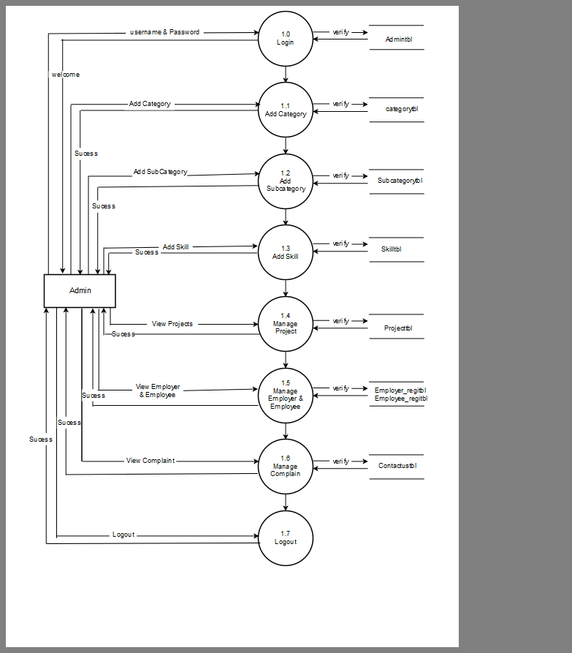

**DFD Level 1 for Employer**

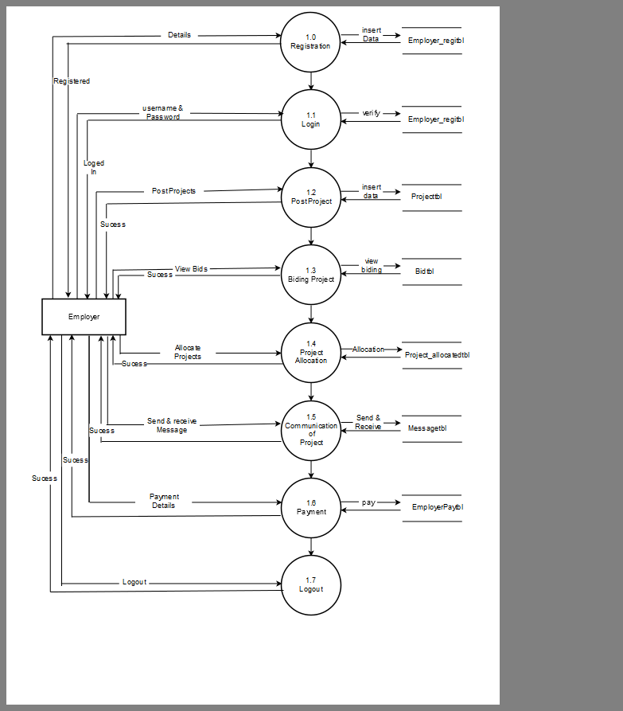

Employer

**DFD level 1 for employee**

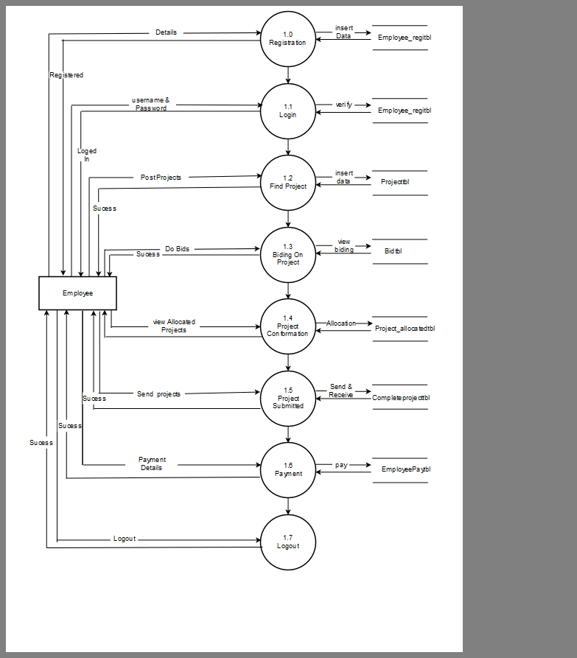

**Activity Diagram:**

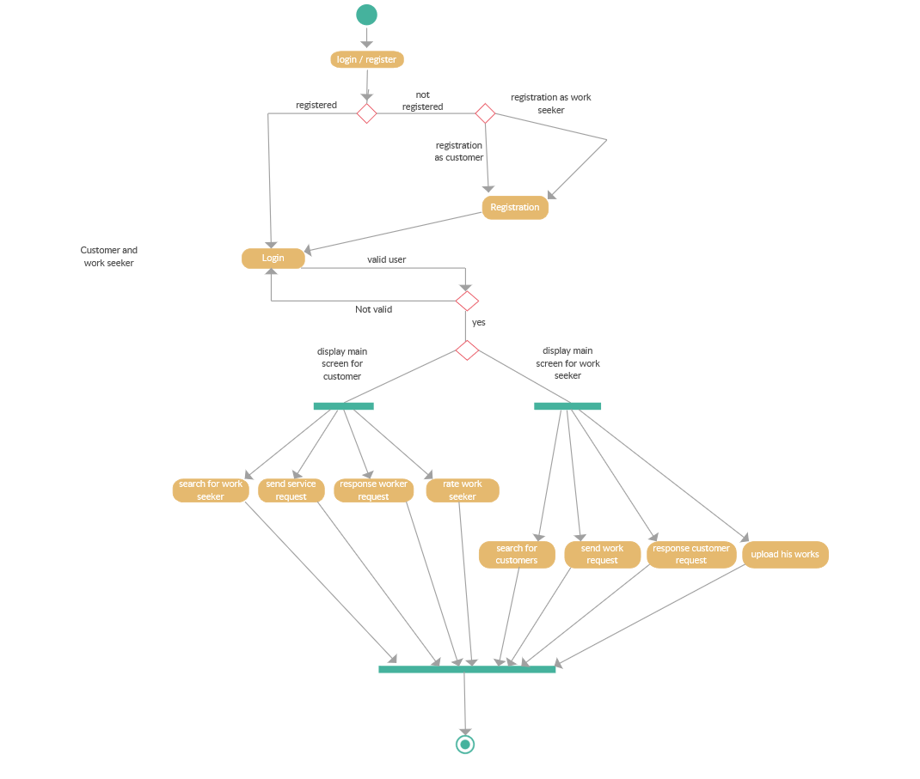

**Process Specification**

Employer Registration

Input :-Personal Details.

Process :-Insert In Database.

Output :-Conformation/Error.

EmployerLogin

Input :-E-mail/Password.

Process :-Insert In Database.

Output :- Login.

Post a Project

Input :-Project Details.

Process :-Insert In Database.

Output :-Successfully Posted.

Employee Registration

Input :-Personal Details.

Process :-Insert In Database.

Output :- Conformation/Error.

EmployeeLogin

Input :-E-mail/Password.

Process :-Check E-mail &Password.

Output :-Login.

Bid On Project

Input :-Budget and Days.

Process :-Verify.

Output :-Bid Accepted.

View Bid

Input :-Project.

Process :-search Bid.

Output :-Bids.

Assign Project

Input :-Freelancer Email.

Process :-Search.

Output :-Winner.

Payment

Input :-Payment Details.

Process :-Insert In Database.

Output :-Payment Done.

Admin Login

Input :-E-mail/Password.

Process :-Check E-mail/Password.

Output :-Email/Password.

Add Category, Subcategory & Skill

Input :-Category, Subcategory & Skills

Process :-Insert In Database.

Output :-Added Successfully.

**4.4 STRUCTURE CHART**

In Structure Chart design, we translate the results of structure analysis which are expressed as data Flow Diagram into a structure chart.

The structure chart mainly depends on the module structure of the software and the interaction among the module.

Some of the structure are commonly used in the structure chart are given below.

Module:-

Linking Module:-

The two modules are connected by an arrow . The Direction of the connecting arrow includes that during program execution control is passes from the one module to other in the direction of the connecting arrow.

Data Flow Arrows:-

Data flow arrow represent the named data moving form the one module to the other in direction of the arrow.

Library Module:-

Library includes the frequently called Modules and is usually represented by rectangle with double edges.

It is predefined module.

Select\decision representation:-

The diamond symbol represent that one module or several modules connected with the diamond is/are invoked upon the condition satisfied.

Connectors and page Continuity:-

Connectors are normally used to avoid crossing line in the chart.

Structure Chart:-

Freelancer

Admin

Employee

Employer

View bids

Insert subcategory

Post Project

h

Insert category,skill

Allocate Projects

View Projects

Payment

View Employee

View Employer

Submit Project

View Projects

Bids on Project

**4.5 Data Dictionary**

**Database Name:Freelancer**

**All Tables:**

|  |  |
| --- | --- |
| **Fields** | **Description** |
| **Employee_regitbl** | This table is used to store all information about Employee who can be registered as employee. |
| **Employer_regitbl** | This table is used to store all information about Employer who can be registered as employer. |
| **Adminlogin** | This table is used to store all information about Admin who can be registered as Admin. |
| **Catetbl** | This table is used to store all information about Category which can be inserted by Admin. |
| **Subcatetbl** | This table is used to store all information about SubCategory which can be inserted by Admin. |
| **Skilltbl** | This table is used to store all information about Skill of employee which can be inserted by Admin. |
| **Contactustbl** | This table is used to store all Messages which can be send by Any user who are registered or not registered. |
| **Prjtbl** | This table is used to store all information about Project which can be Posted by Employer. |
| **prj_allocated** | This table is used to store all information about Allocated Project which can be Allocated by Employer. |
| **Message** | This table is used to store all Messages which can be send by Employee and Employer. |
| **Bidtbl** | This table is used to store all information about Biding on project which can be done by Employee. |
| **Choosed_skill** | This table is used to store all information about Skill which can be Selected by Employee. |
| **Completeprj** | This table is used to store all information about Complete Project which can be Complete by Employee. |
| **Employee_acc** | This table is used to store all information about employee account which can be Managed by Employee. |
| **Employerpaytbl** | This table is used to store all information about Paid Project which can be managed by Employer. |

**Employee_regitbl:**

This table is used to store all information about Employee who can be registered as employee.

|  |  |  |  |
| --- | --- | --- | --- |
| **Fields** | **Type** | **constraints** | **Description** |
| employee_id | int(11) | Auto increment | Used to store id. |
| Fn | Text | Not Null | Store first name. |
| Ln | Text | Not Null | Store last name. |
| Em | Text | Not Null | Store email address. |
| Un | Text | Not Null | Store user name. |
| Pass | Text | Not Null | Store password. |
| cn1 | Text | Not Null | Store mobile number. |
| cn2 | Text | Not Null | Store mobile number. |
| Address | Text | Not Null | Store address. |
| City | Text | Not Null | Store city name. |
| Que | Text | Not Null | Store question. |
| Ans | Text | Not Null | Store answer. |
| Balance | int(11) | Not Null | Store balance for empl. |
| Img_upld | Text | Not Null | Store employee image. |

**Employer_regitbl:**

This table is used to store all information about Employer who can be registered as employer.

|  |  |  |  |
| --- | --- | --- | --- |
| **Fields** | **Type** | **constraints** | **Description** |
| employer_id | int(11) | Auto increment | Used to store id. |
| Fn | Text | Not Null | Store first name. |
| Ln | Text | Not Null | Store last name. |
| Em | Text | Not Null | Store email address. |
| Un | text | Not Null | Store user name. |
| Pass | text | Not Null | Store password. |
| Cnm | text | Not Null | Store company name. |
| Cadd | text | Not Null | Store company address. |
| Cem | text | Not Null | Store company email. |
| cn1 | text | Not Null | Store mobile number. |
| City | text | Not Null | Store city name. |
| Que | text | Not Null | Store question. |
| Ans | text | Not Null | Store answer. |
| Balance | int(11) | Not Null | Store balance for empl. |
| Img_upld | text | Not Null | Store employer image. |

**Adminlogin:**

This table is used to store all information about Admin who can be registered as Admin.

|  |  |  |  |
| --- | --- | --- | --- |
| **Fields** | **Type** | **constraints** | **Description** |
| Admid | int(11) | Auto increment | Used to store admin id. |
| Admemail | text | Not Null | Store admin email. |
| Admpass | text | Not Null | Store admin pass. |
| Admdp | text | Not Null | Store admin dp. |
| Secque | text | Not Null | Store admin question. |
| Secans | text | Not Null | Store admin answer. |

**Catetbl:**

This table is used to store all information about Category which can be inserted by Admin.

|  |  |  |  |
| --- | --- | --- | --- |
| **Fields** | **Type** | **constraints** | **Description** |
| cate_id | int(11) | Auto increment | Used to store id. |
| cate_name | text | Not Null | Store category name. |

**Subcatetbl:**

This table is used to store all information about SubCategory which can be inserted by Admin.

|  |  |  |  |
| --- | --- | --- | --- |
| **Fields** | **Type** | **constraints** | **Description** |
| sub_id | int(11) | Auto increment | Used to store id. |
| sub_name | text | Not Null | Store subcategory name |
| cate_id | int(11) | Not Null | Store category id. |

**Skilltbl:**

This table is used to store all information about Skill of employee which can be inserted by Admin.

|  |  |  |  |
| --- | --- | --- | --- |
| Fields | Type | constraints | Description |
| skill_id | int(11) | Auto increment | Used to store skill id. |
| skill_name | text | Not Null | Store skill name. |
| cate_id | int(11) | Not Null | Store category id. |
| sub_id | int(11) | Not Null | Store sub-category id. |

**Contactustbl:**

This table is used to store all Messages which can be send by Any user who are registered or not registered.

|  |  |  |  |
| --- | --- | --- | --- |
| **Fields** | **Type** | **constraints** | **Description** |
| comp_id | int(11) | Auto increment | Used to store comp. id. |
| Email | text | Not Null | Store email employer. |
| Subject | text | Not Null | Store subject to contact |
| Msg | text | Not Null | Store message for cont. |

**Prjtbl:**

This table is used to store all information about Project which can be Posted by Employer.

|  |  |  |  |
| --- | --- | --- | --- |
| **Fields** | **Type** | **constraints** | **Description** |
| p_id | int(11) | Auto increment | Used to store project id. |
| employer_id | int(11) | Not Null | Store employer id. |
| p_name | text | Not Null | Store project name. |
| cate_id | int(11) | Not Null | Store category id. |
| skill_id | int(11) | Not Null | Store skill id. |
| Details | text | Not Null | Store project details. |
| Budget | text | Not Null | Store project budget. |
| Days | int(11) | Not Null | Store day of completion |
| Files | text | Not Null | Store attachment file. |
| Date | date | Not Null | Store date of posted. |

**prj_allocated:**

This table is used to store all information about Allocated Project which can be Allocated by Employer.

|  |  |  |  |
| --- | --- | --- | --- |
| **Fields** | **Type** | **constraints** | **Description** |
| allocated_id | int(11) | Auto increment | Used to storeallo.prj id. |
| employer_id | int(11) | Not Null | Store employer id. |
| employee_id | int(11) | Not Null | Store employee id. |
| p_id | int(11) | Not Null | Store project id. |
| Budget | int(11) | Not Null | Store project budget. |
| Date | date | Not Null | Store date of posted. |

**Message:**

This table is used to store all Messages which can be send by Employee and Employer.

|  |  |  |  |
| --- | --- | --- | --- |
| **Fields** | **Type** | **constraints** | **Description** |
| Id | int(11) | Auto increment | Store message id. |
| p_id | int(11) | Not Null | Store project id. |
| Username | text | Not Null | Store username value. |
| Message | text | Not Null | Store the message. |

**Bidtbl:**

This table is used to store all information about Biding on project which can be done by Employee.

|  |  |  |  |
| --- | --- | --- | --- |
| **Fields** | **Type** | **constraints** | **Description** |
| bid_id | int(11) | Auto increment | Used to store biding id. |
| employer_id | int(11) | Not Null | Store employer id. |
| employee_id | int(11) | Not Null | Store employee id. |
| Budget | text | Not Null | Store project budget . |
| Days | int(11) | Auto increment | Store the day to compl. |
| project_id | int(11) | Not Null | Store project id. |
| Status | text | Not Null | Store now prj. Status. |
| Date | date | Not Null | Store date of posted. |

**Choosed_skill:**

This table is used to store all information about Skill which can be Selected by Employee.

|  |  |  |  |
| --- | --- | --- | --- |
| **Fields** | **Type** | **constraints** | **Description** |
| cs_id | int(11) | Auto increment | Used to store choose id. |
| skill_id | int(11) | Not Null | Store skill id. |
| employee_id | int(11) | Not Null | Store employee id. |

**Completeprj:**

This table is used to store all information about Complete Project which can be Complete by Employee.

|  |  |  |  |
| --- | --- | --- | --- |
| **Fields** | **Type** | **constraints** | **Description** |
| completeprj_id | int(11) | Auto increment | Used to complete prj id. |
| employer_id | int(11) | Not Null | Store employer id. |
| employee_id | int(11) | Not Null | Store employee id. |
| Prjfile | text | Not Null | Store comp. project file |
| complete_date | date | Not Null | Store date of completion |

**Employee_acc:**

This table is used to store all information about employee account which can be Managed by Employee.

|  |  |  |  |
| --- | --- | --- | --- |
| **Fields** | **Type** | **constraints** | **Description** |
| acc_id | int(11) | Auto increment | Used to account id. |
| employee_id | int(11) | Not Null | Store employee id. |
| Name | text | Not Null | Store account name. |
| ac_no | text | Not Null | Store account number. |

**Employerpaytbl:**

This table is used to store all information about Paid Project which can be managed by Employer.

|  |  |  |  |
| --- | --- | --- | --- |
| **Fields** | **Type** | **constraints** | **Description** |
| employerpay_id | int(11) | Auto increment | Used to complete prj id. |
| p_id | int(11) | Not Null | Store project id. |
| Amount | int(11) | Not Null | Store amount of emplr. |
| employer_id | int(11) | Not Null | Store employer id. |
| employee_id | int(11) | Not Null | Store employee id. |

**5.1 Web Layout**

**HomePage**

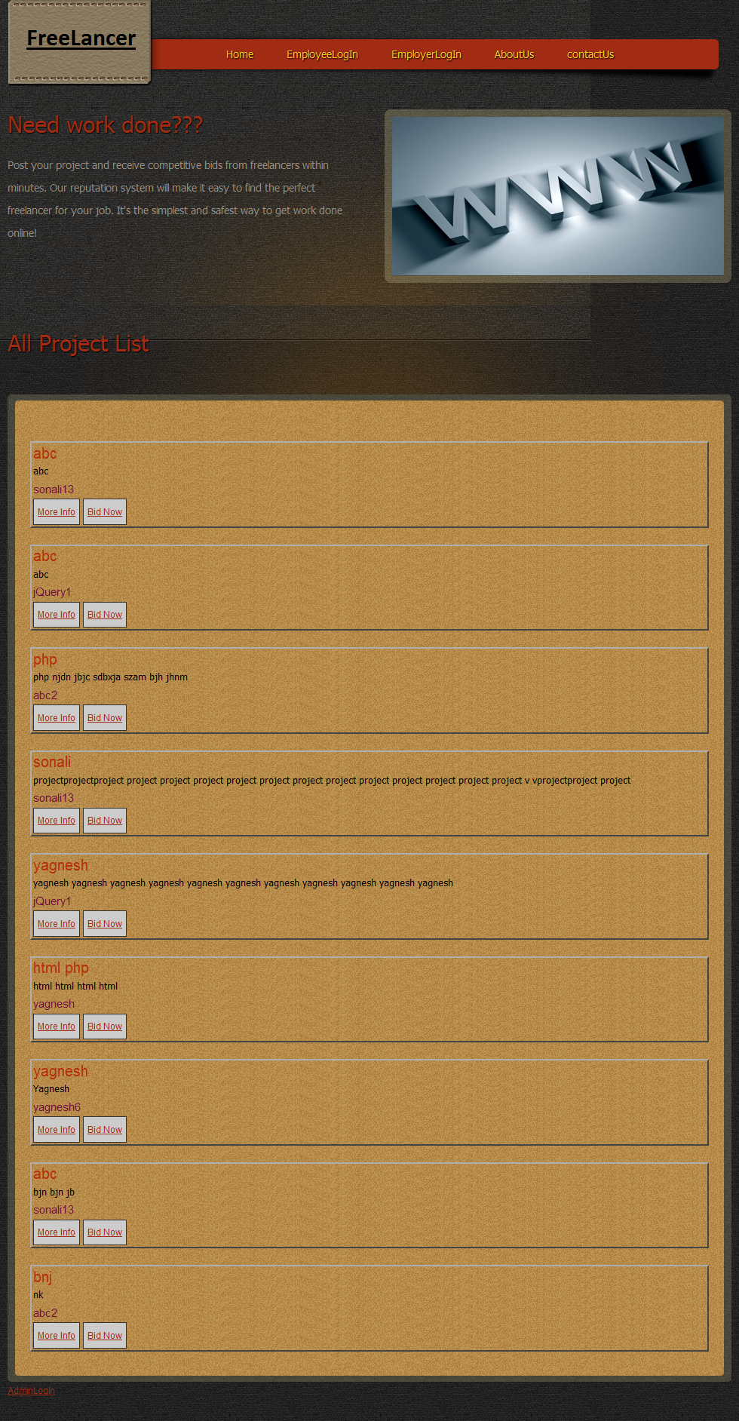

**Employee Login**

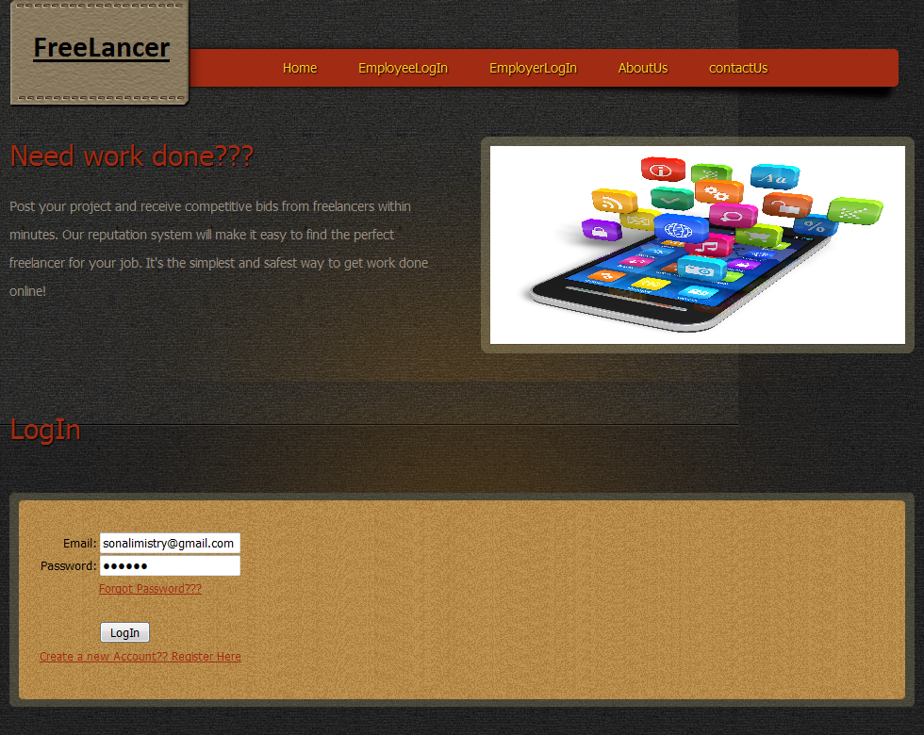

**Employer Login**

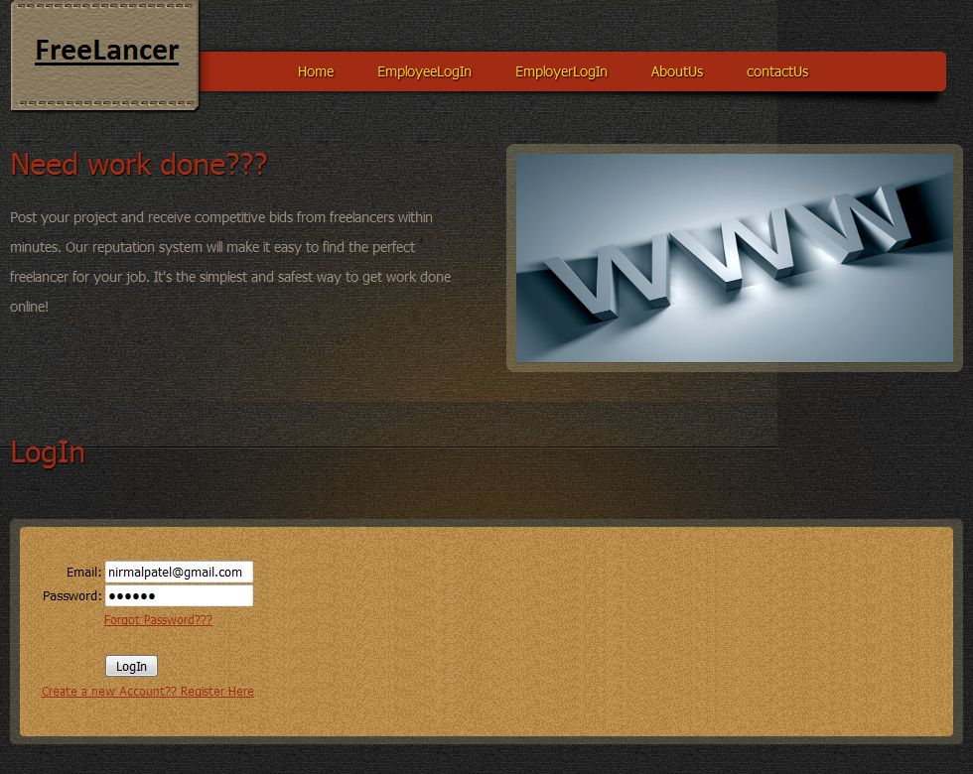

**About Us**

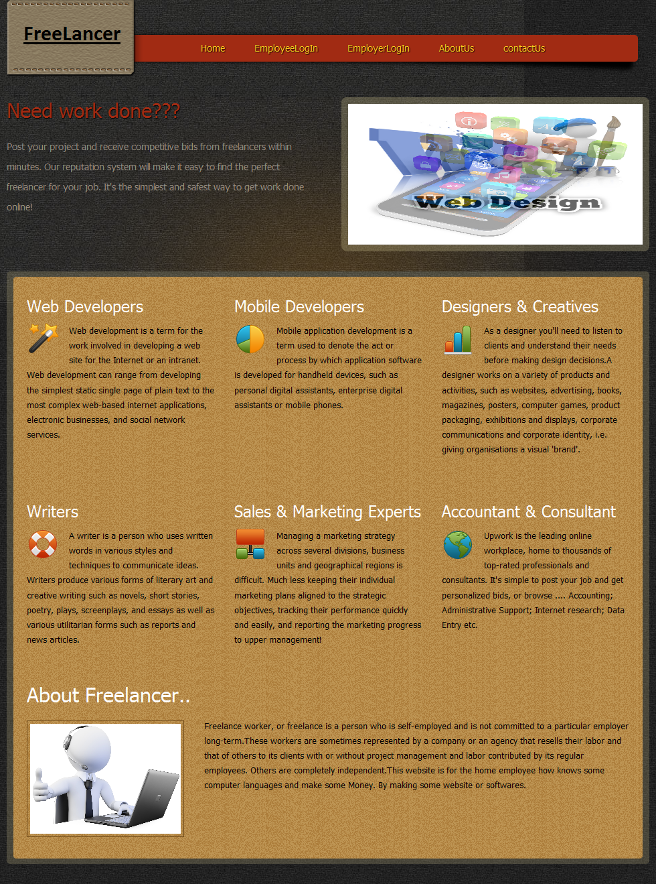

**Contact Us**

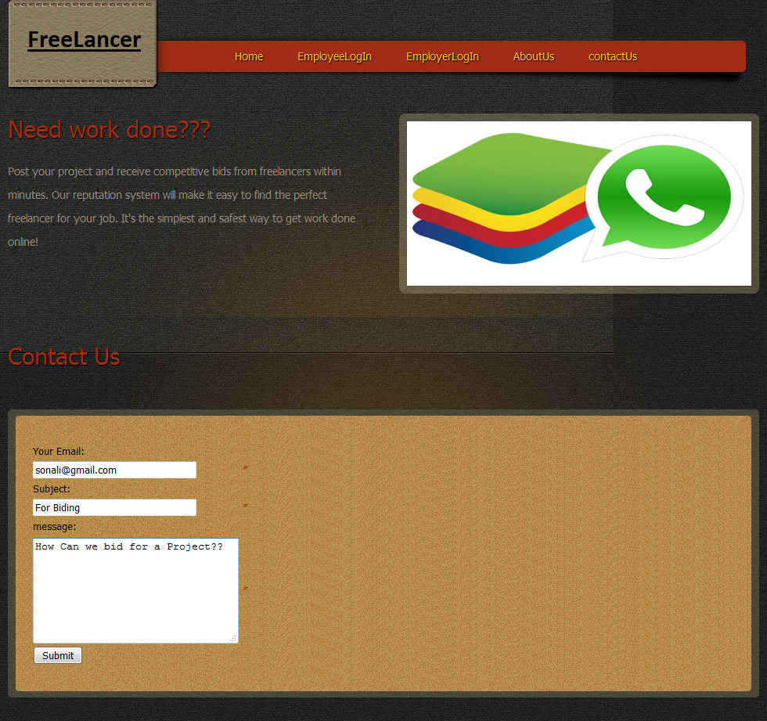

**Admin Login**

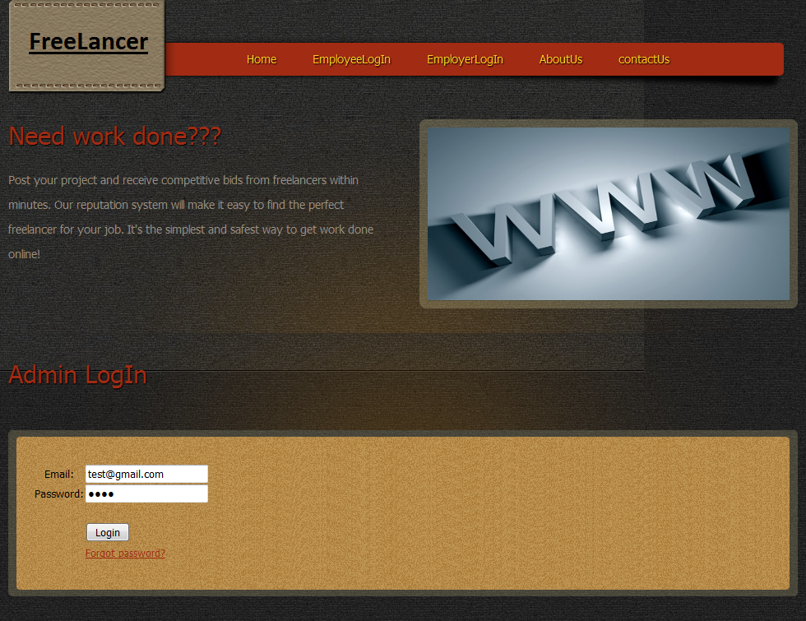

**Admin Home**

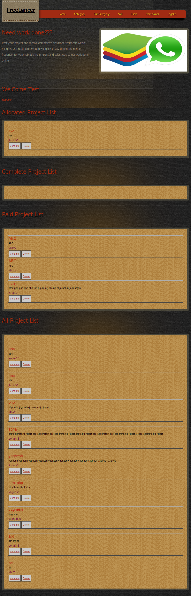

**Category Page**

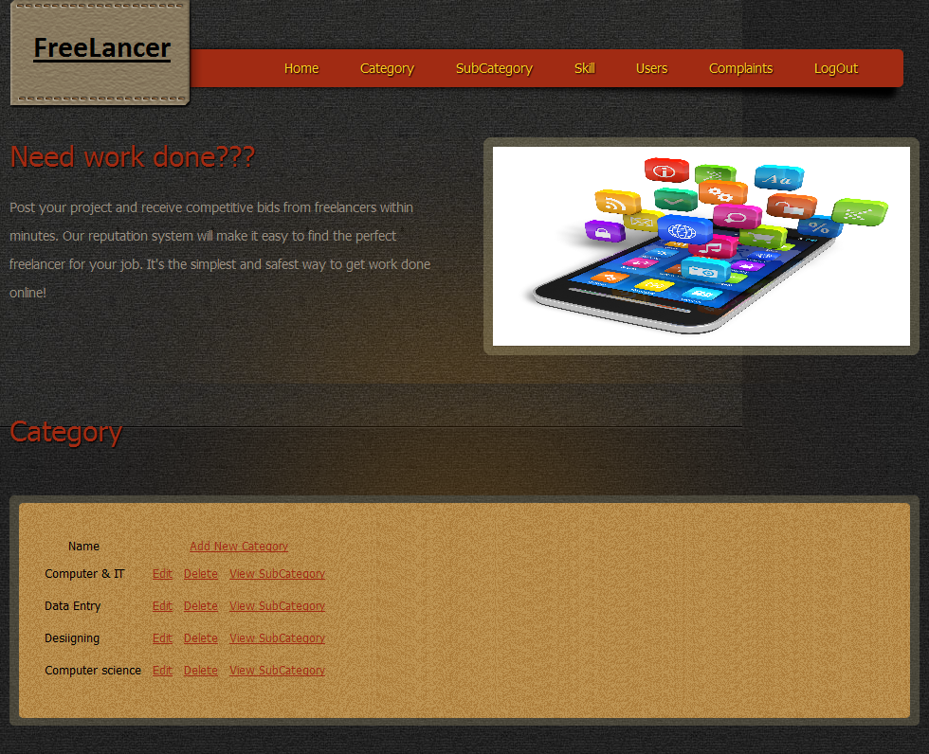

**Subcategory Page**

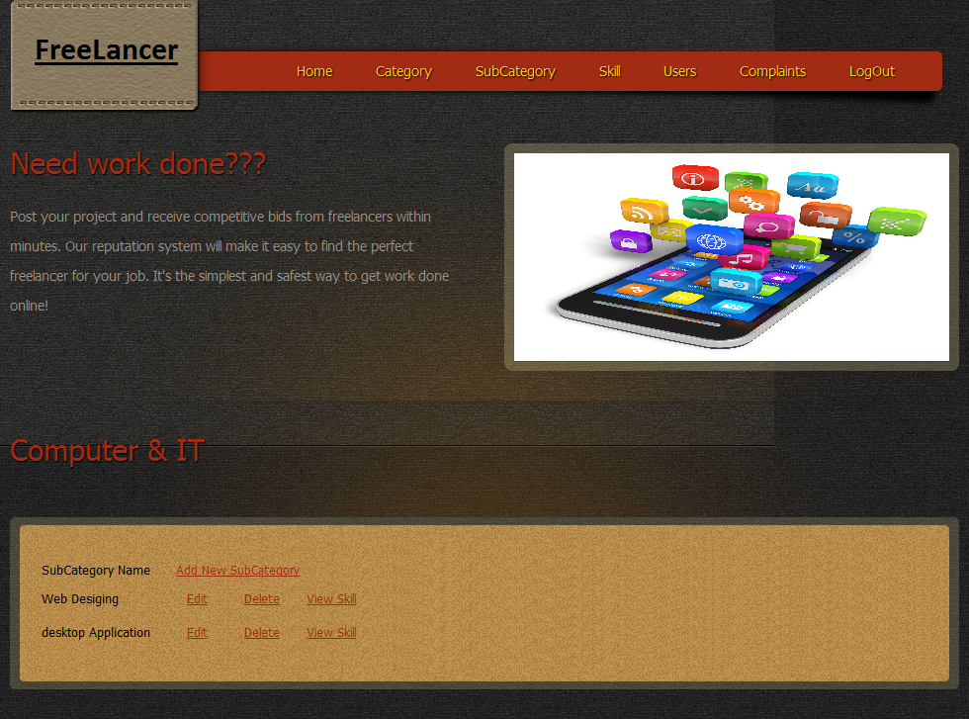

**Subcategory Page**

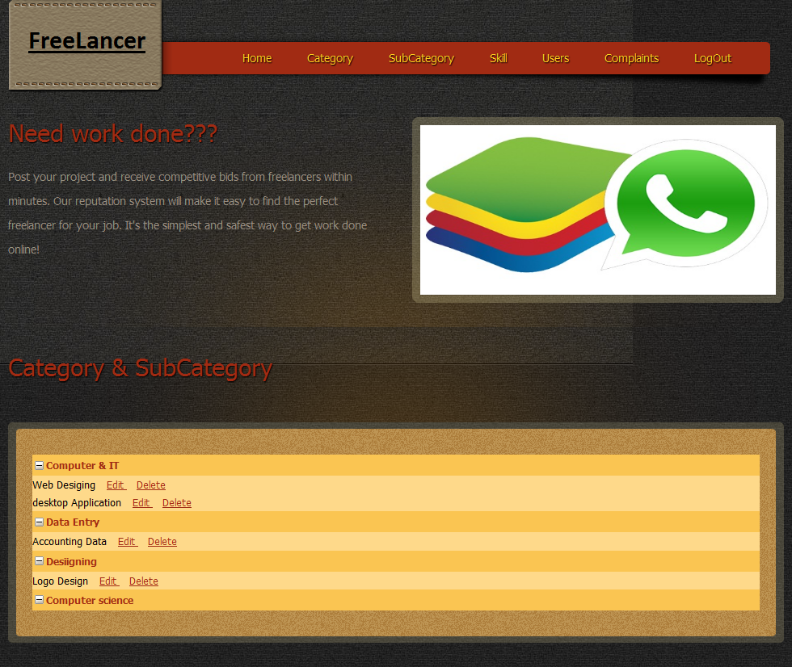

**Skill Page**

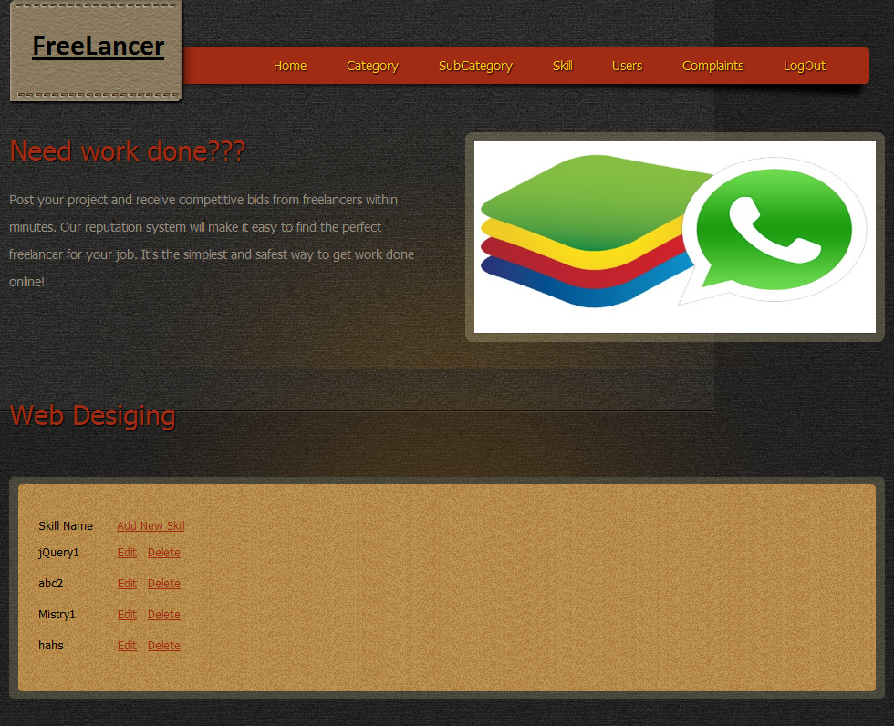

**Skill Page**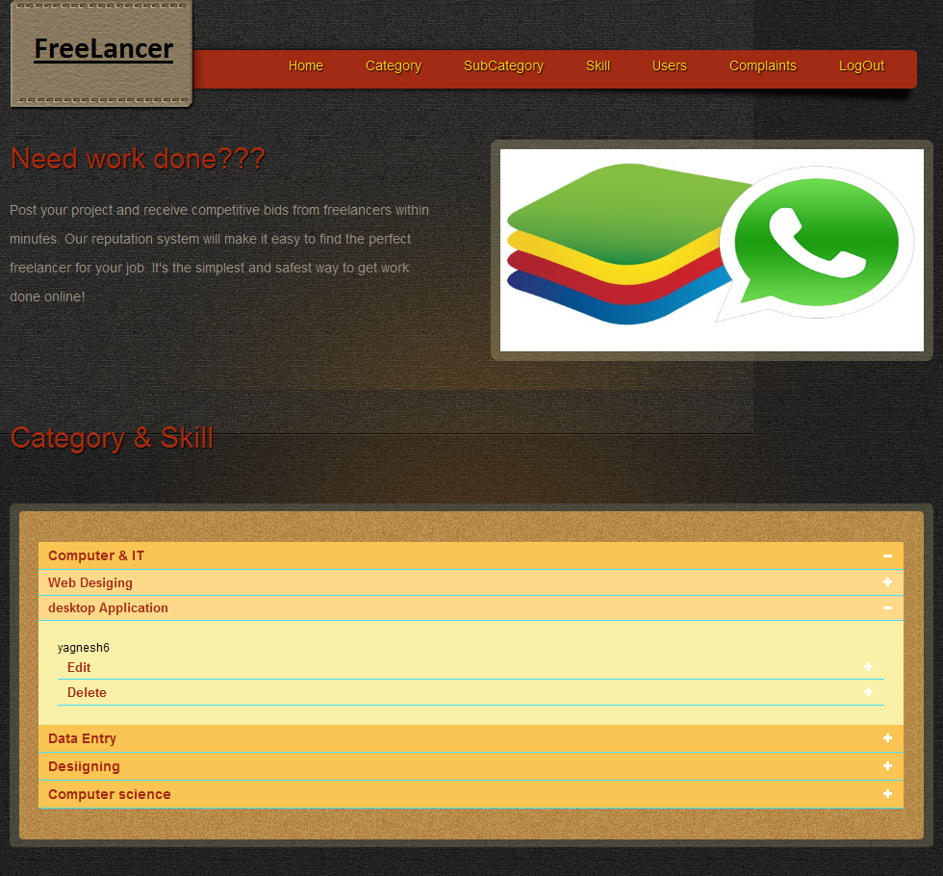

**Employee Registration**

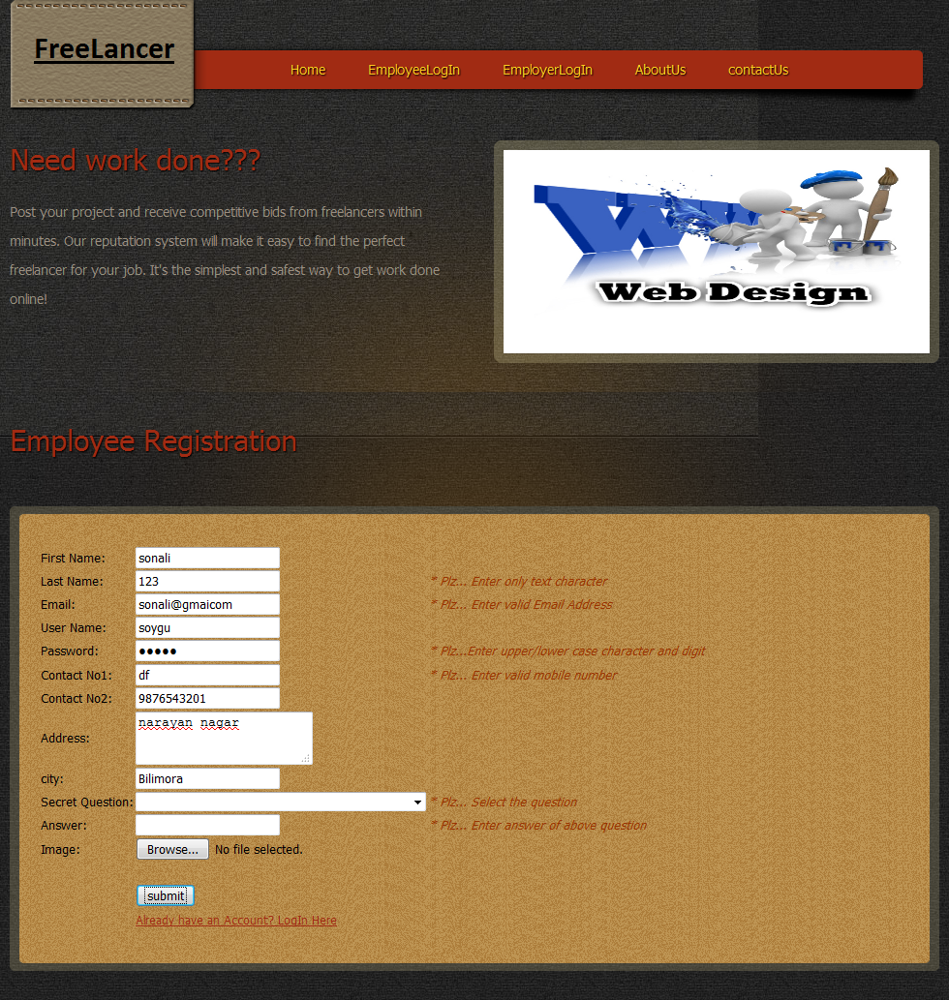

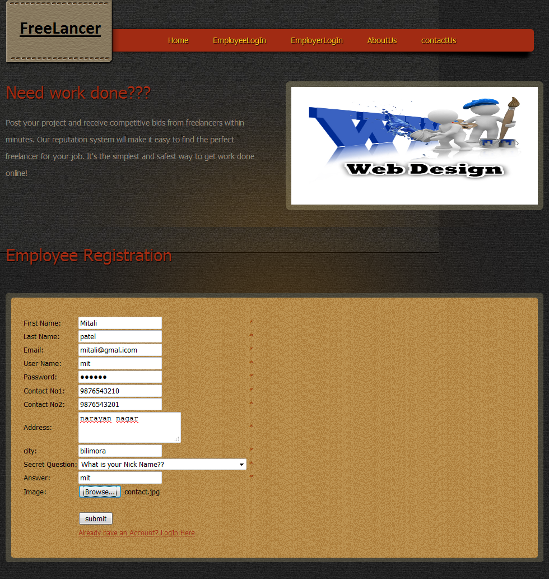

**Employee Home**

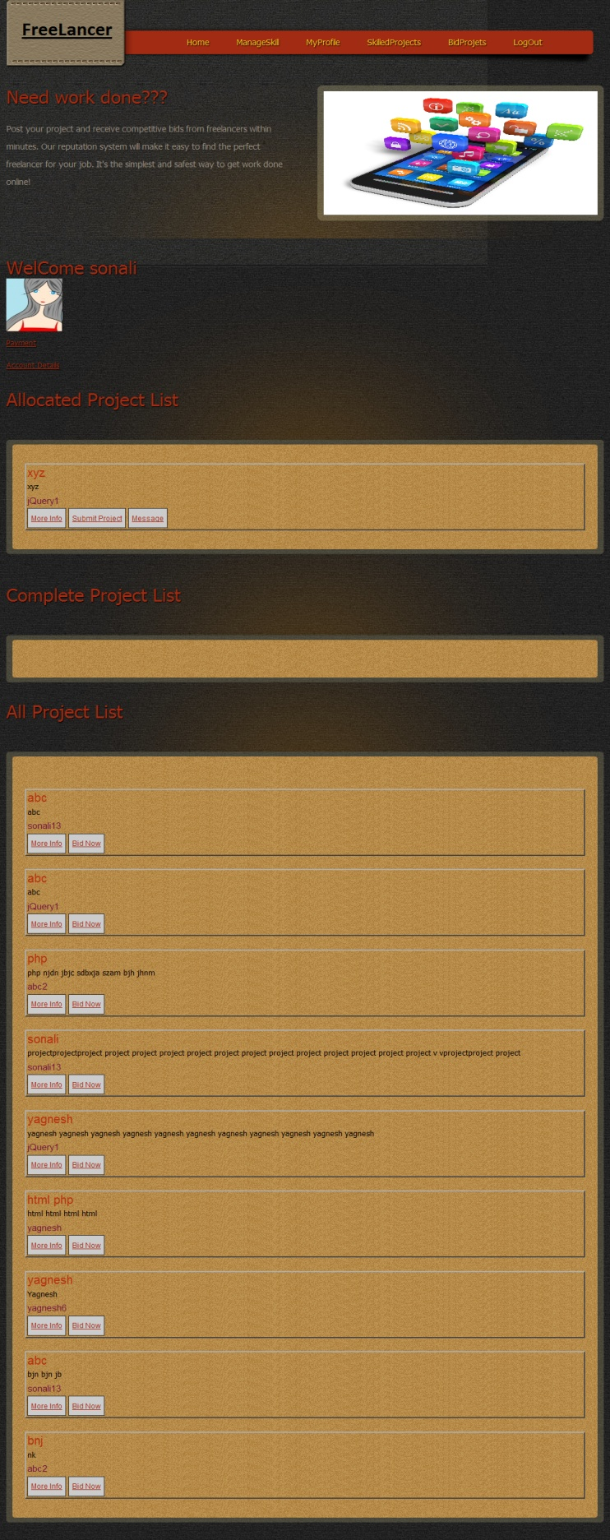

**Manage Skill**

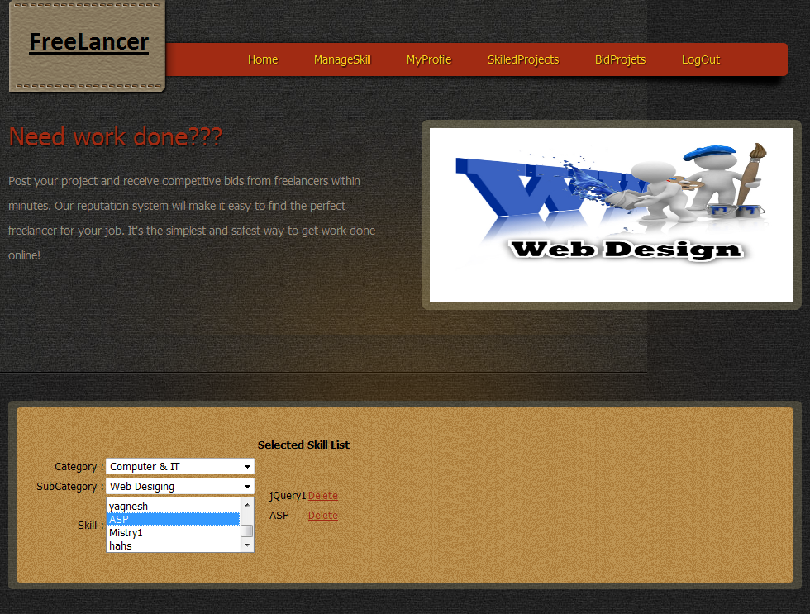

**Skilled Project**

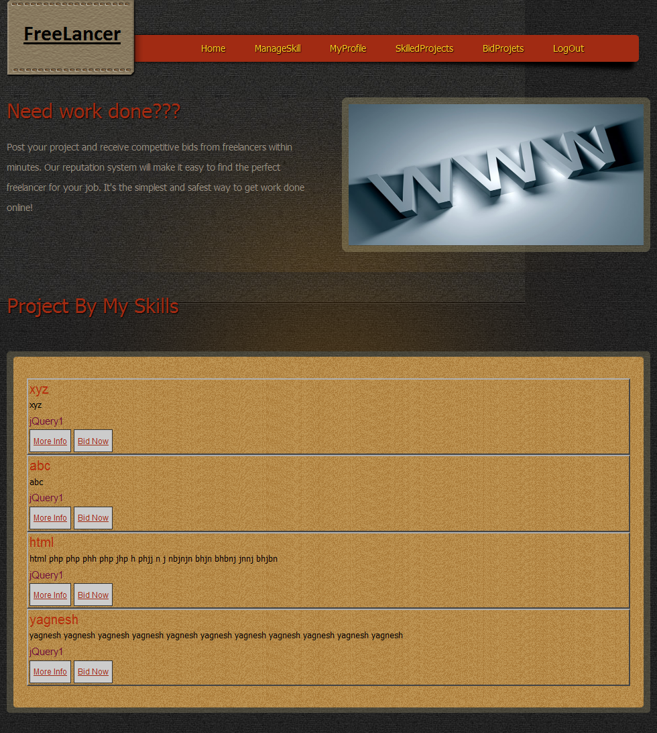

**Bid Projects**

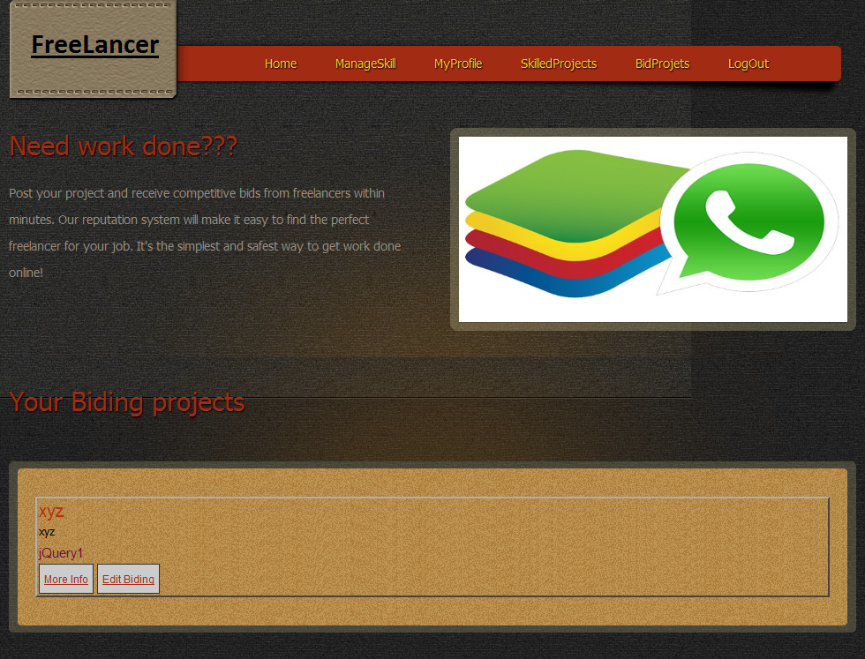

**Employer Registration**

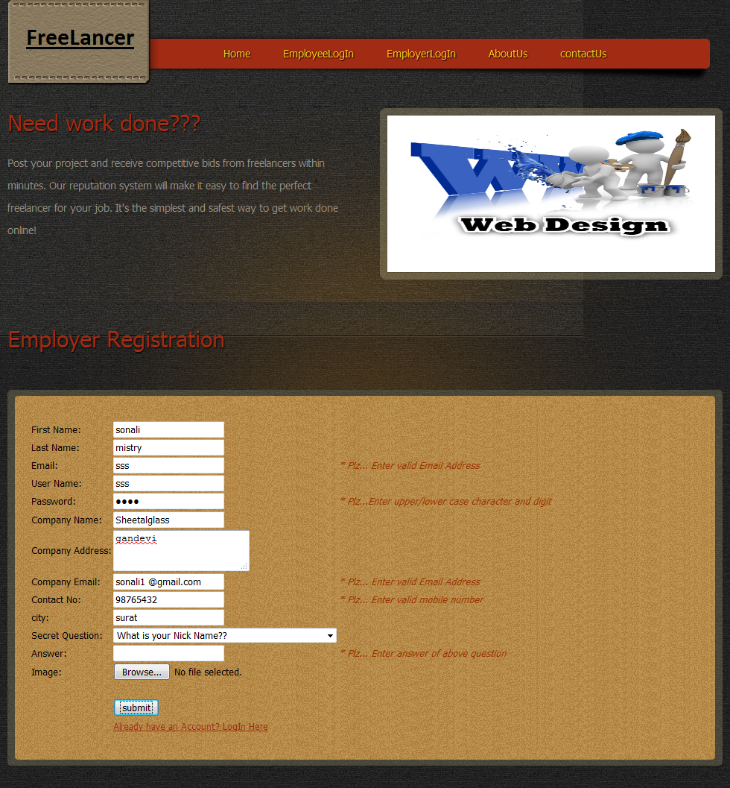

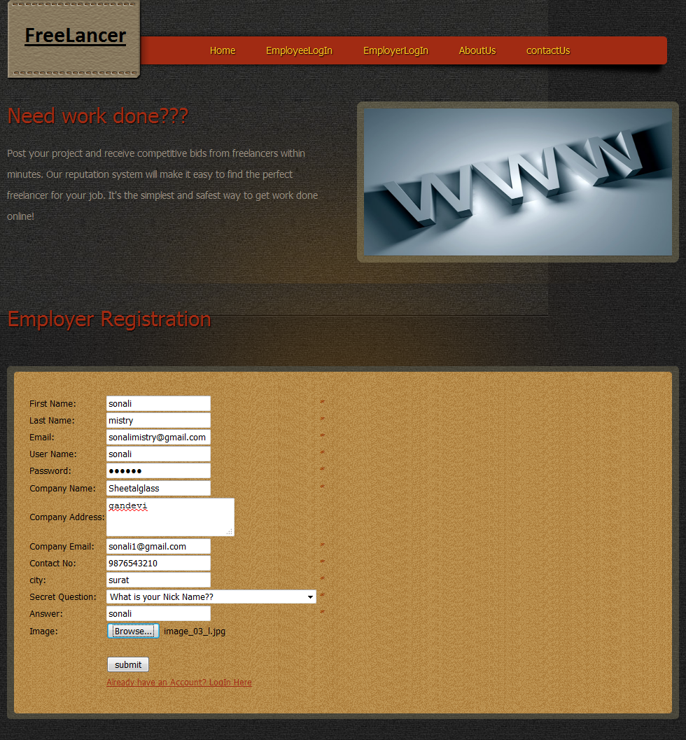

**Employer Home**

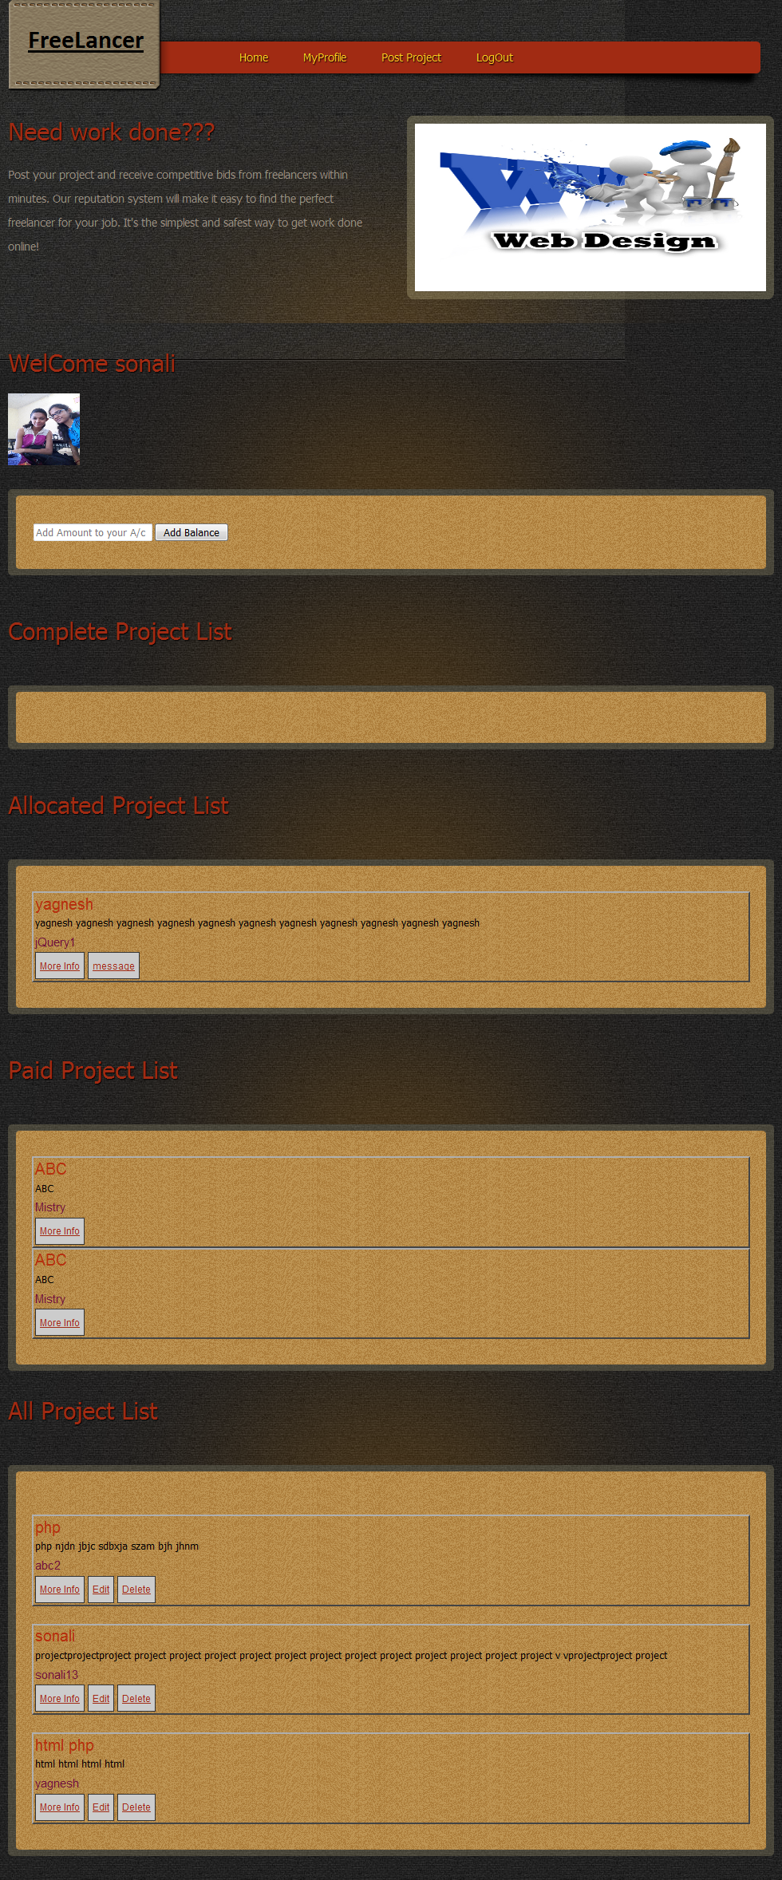

**Post Project**

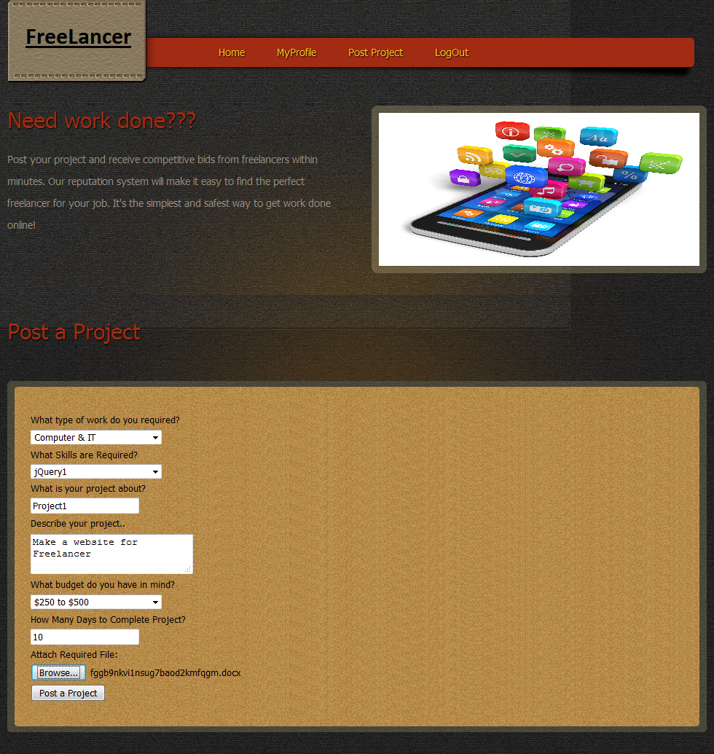

**Allocate Project**

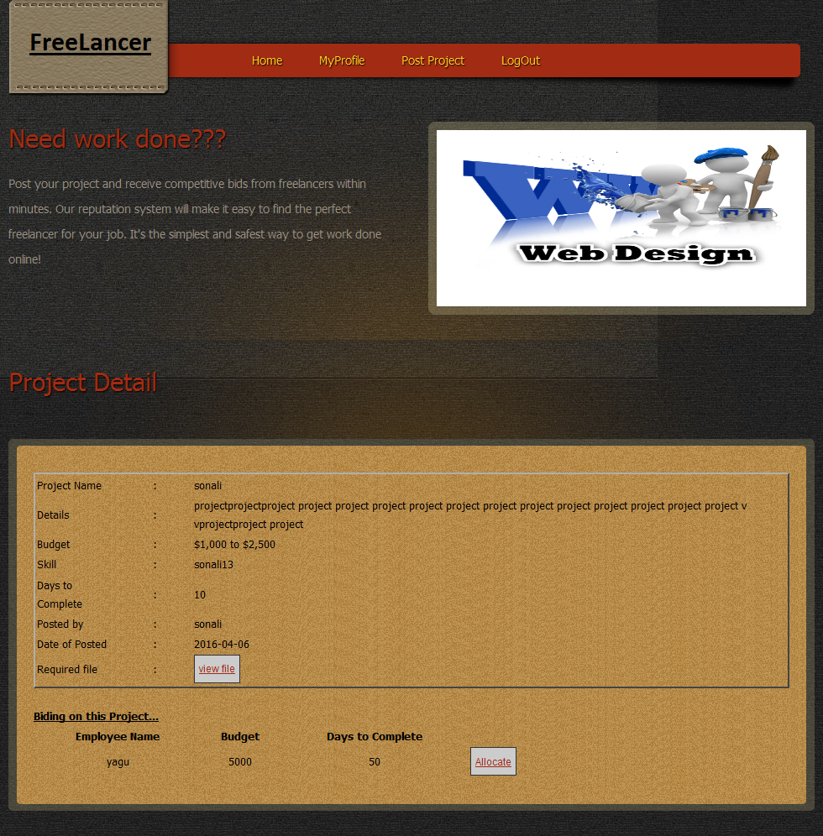

**Message**

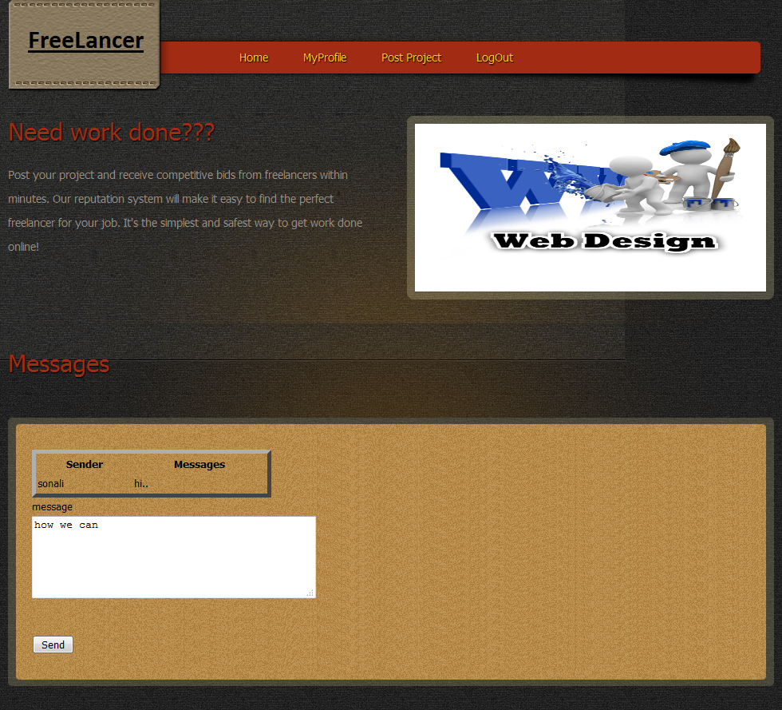

**5.2 Report**

**Admin Report**

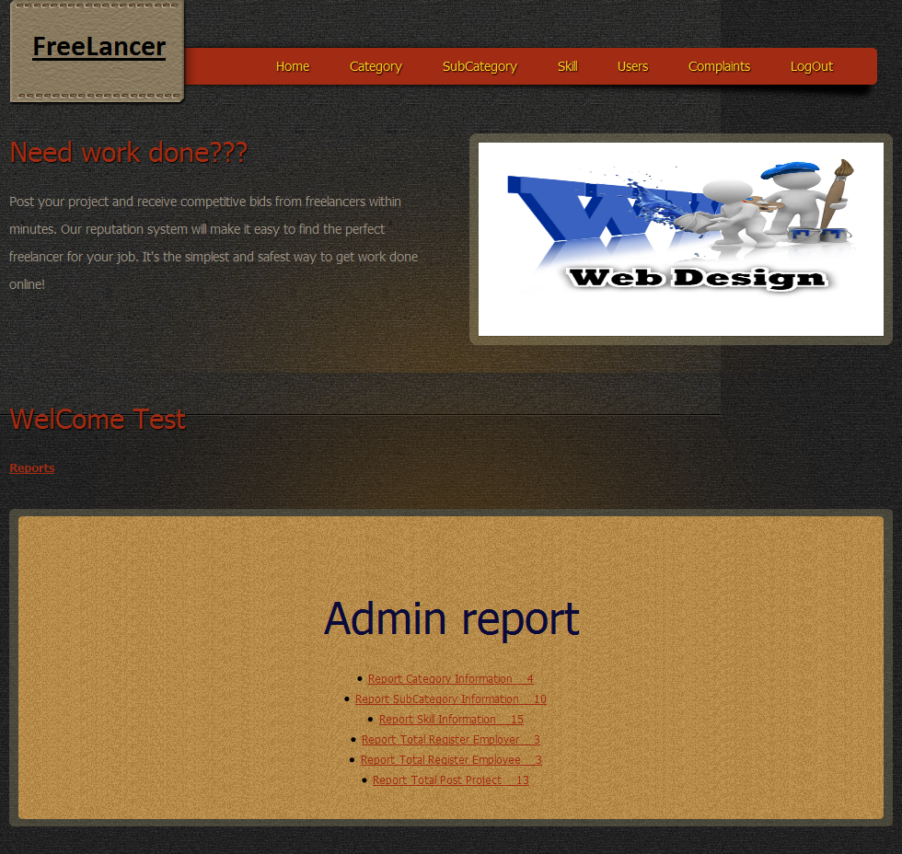

**Category Report**

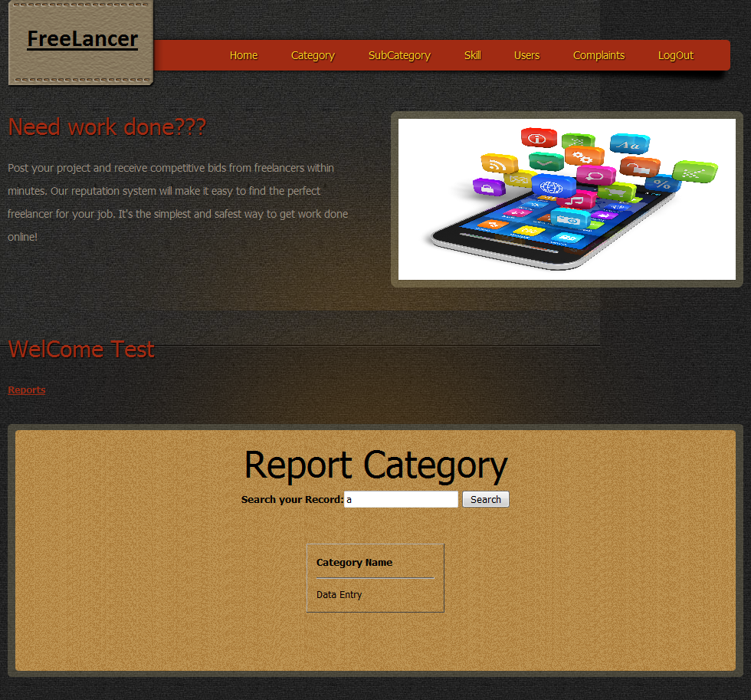

**SubCategory Report**

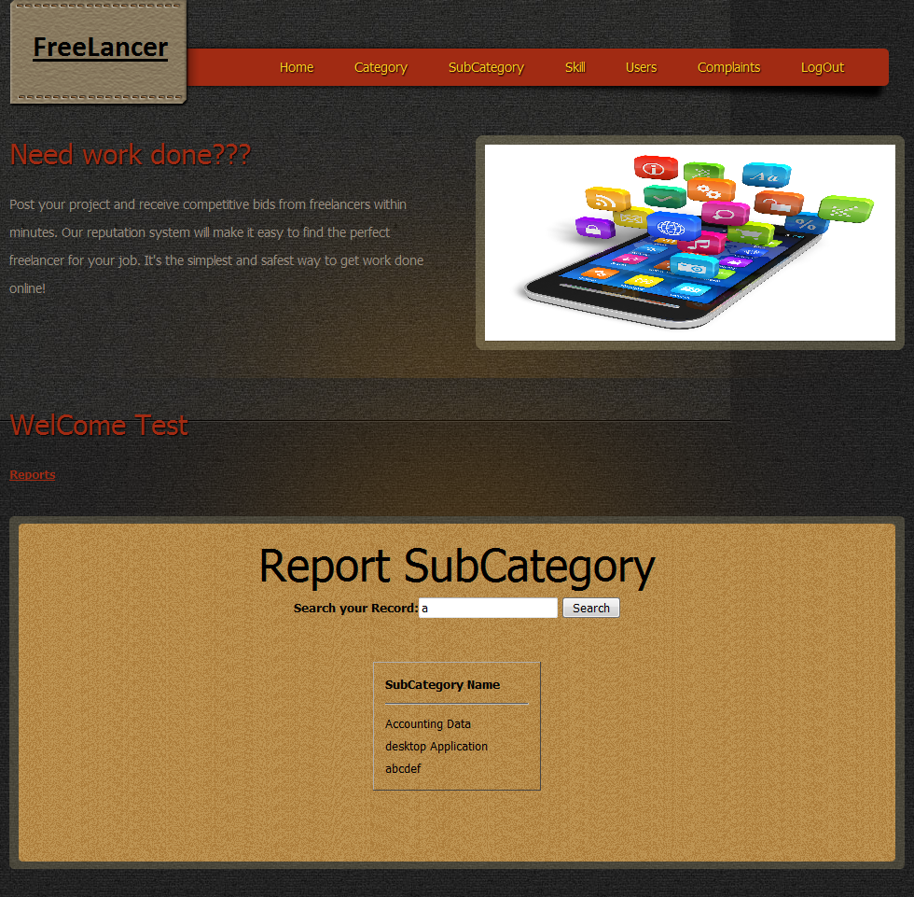

**Skill Report**

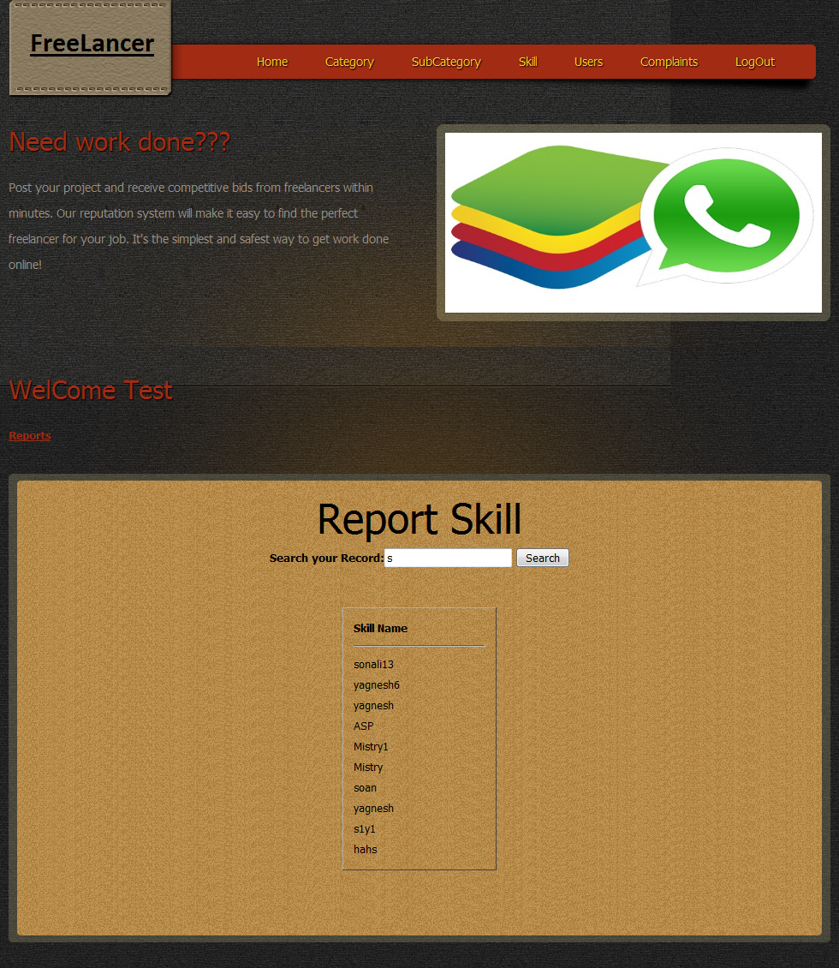

**Employer Report**

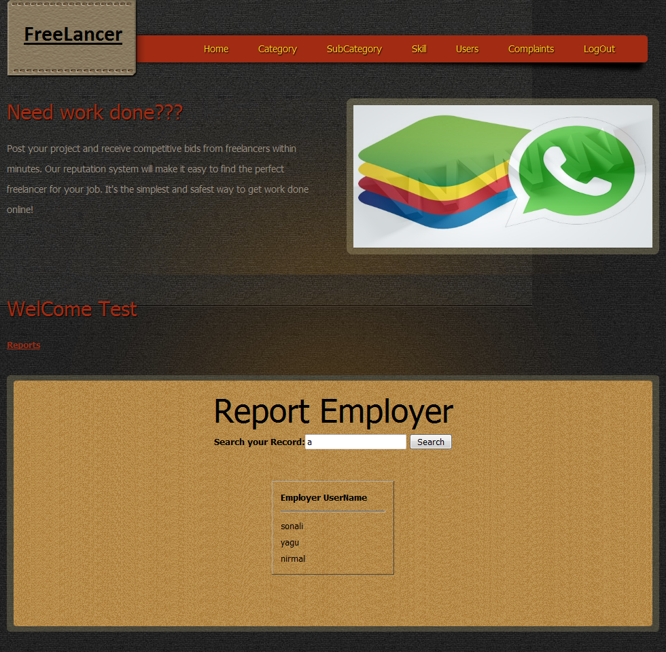

**Employee Report**

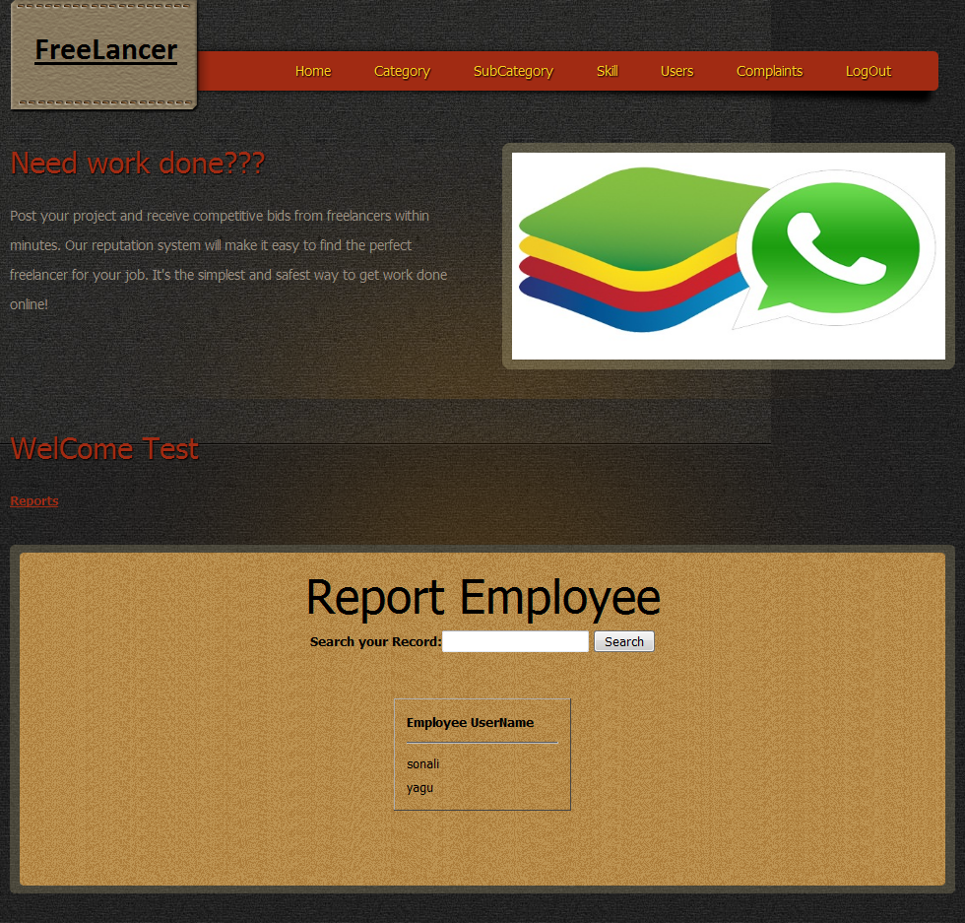

**Project Report**

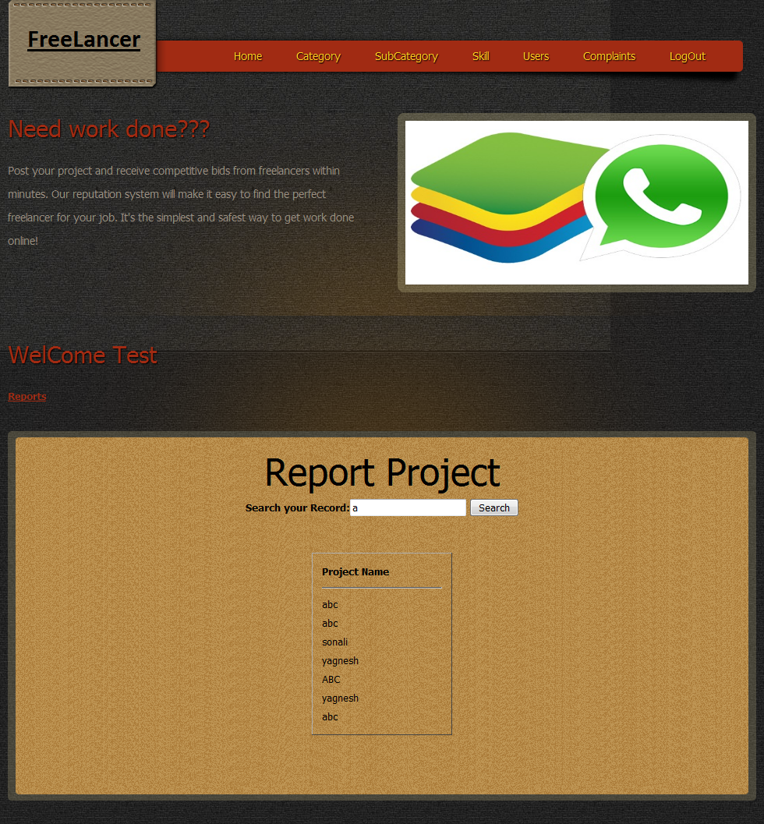

**5.3 Testing**

Testing is a process of executing of program with intense of finding an error.

The basic goal of the software development process is to produce software that has no errors or very few errors.In an effort to detect error soon after they are introduce, each phase ends with a verification

Activity such as review however most of this verification activites in the early phases of software development are based on human evolution and cannot detect all the errors. This unreliability of the quality assurance activites in the early part of the development cycle phase a very high responsibility on testing. In order word, as testing is the last phase before the final software is delivered, it has the enormous responsibility of detecting any type of error that may be in software.

The stages in the testing process are:

**Unit Testing:-**

Individual components are tested to ensure that they operate correctly. Each component is tested independently without other system components.

**Module Testing:-**

A module collection of dependent components such as an object class, an abstract data type or some looser collection producer and functions. A module encapsulates collection producer and function. A module encapsulates related components so that it can be teste without other system module.

**Sub-System Testing:-**

This phase involved testing collection of modules which have been integrated into sub system. Sub- system may be independently designed and implemented. The most common problems which arise in large software or sub-systems interface mismatches. The sub-system test process sod there concentrate on the detection of interface errors by rigorously excreting these interfaces.

**System Testing:-**

The sub-system are integrated to make the entire system. The testing process is conserved with finding errors which normally results from unanticipated interaction between sub-system and components.it also concerned with validation the system meets it functional and nonfunctional requirements.

**Acceptance Testing:-**

This is the final test in the testing process before the system accepted for operational use it is some time called alpha testing.it involves testing the system data with supplied by system procurer rather than simulated data developed as part of the testing process.it often reveals errors and omission in the system definition .

**Future Scope**

Easy to find project in the world.

Employee can find project a project after registration.

Employee can find out project related to its criteria.

Employer can provide projects.

It provides all types of project.

It includes various types of facility advertisement, SMS sent.

Everything will be validation.

Payment of employee in working in freelancer.

Message chatting of personal employee and employer in website.

**Bibliography**

The Websites which are referred to complete this project are as below

**Website:**

* <http://www.w3schools.com/sql/sql_distinct.asp>
* <http://www.plus2net.com/jquery/dropdown-list-double.php>
* [http://www.cssscript.com/demo/multilevel-accordion-menu-with-plain-html-css/#](http://www.cssscript.com/demo/multilevel-accordion-menu-with-plain-html-css/)
* <http://www.91weblessons.com/php-ajax-country-state-city-drop-down/>
* <http://www.thesoftwareguy.in/upload-and-save-image-with-php-and-mysql/>